





UDHNA CITIZEN COMMERCE COLLEGE & S.P.B COLLEGE OF BUSINESS
ADMINISTATRATION & SMT.DIWALIBENHAR GONDALIA COLLEGE OF BCA AND I.T.
Bachelor of computer application (BCA) Programme


Minor Project Report
BCA Sem – 5
Year: 2025 -2026
Class: TYBCA - F
Group no. – WFS_A209

Project Title: Code Café (Café Management System)
Submitted By
Roll No. | Seat No. | Name of Student
2548008 | 4752 | Devendra P Sonawane
2548032 | 4330 | Das Shivam Dharmendrabhai
2548005 | 4215 | Yadav Dipika MahendraPrasad

Project Guided By: -
Prof. Nisarg Naik

INDEX
Chapter No. | Chapter Name | Page No.
1. | Introduction
2. | Limitation of Existing system
3. | Objectives
4. | Scope
5. | Advantages
6. | System Design
7. | Teck Stack
8. | Screenshots
9. | Coding
10. | References

1. Introduction
Coffee has always been more than just a beverage; it is a culture, a daily ritual, and for many, an essential part of their lifestyle. Over the years, coffee consumption has evolved from traditional homemade brews to modern, specialized coffee shop experiences.
In today’s fast-paced world, convenience has become a crucial factor for customers. They expect quick service, personalized experiences, and the ability to access products anytime, anywhere. Traditionally, coffee shop operations rely on manual processes where customers physically visit the store, wait in line, and place their orders. While this approach works, it often leads to inefficiencies such as long queues, incorrect orders due to miscommunication, and delays during peak hours. Moreover, keeping track of customer preferences and order history becomes challenging when everything is done manually.
To address these issues, there has been a growing need for digital transformation in the coffee shop industry. Many businesses, including have started integrating technology into their operations to streamline processes and enhance customer satisfaction. A digital ordering system not only speeds up service but also provides valuable insights to store managers and improves inventory and sales tracking.
The Code Café Coffee Shop Ordering System project is a step toward modernizing the coffee ordering process by offering a web-based platform that simplifies interactions between the coffee shop and its customers. This system allows customers to browse the Code Café menu, select their desired beverages, customize their orders, and place them online with ease. By introducing features such as user registration, secure login, and order history tracking, the system ensures a personalized and secure experience for every customer.
From the perspective of the coffee shop management, this system provides tools to manage menu items, view active and past orders, and analyse customer trends. By digitizing these tasks, the coffee shop can reduce manual workload, minimize errors, and improve overall operational efficiency.
This project is developed using PHP for backend development, MySQL for database management, and HTML, CSS, and JavaScript for the frontend interface. The choice of these technologies ensures that the system is lightweight, scalable, and easy to maintain. The database securely stores all essential data, including customer information, menu details, and order transactions, enabling quick and accurate data retrieval whenever needed.
The system has been designed with a user-centric approach, keeping in mind both customer convenience and business requirements. It allows Code Café customers to experience the same quality service online as they would receive at a physical store. Additionally, the platform sets the foundation for integrating advanced features in the future, such as online payment gateways, delivery tracking, and loyalty programs.
In summary, the Code Café Coffee Shop Ordering System aims to:
- Enhance the customer experience by providing a fast and easy ordering process.
- Reduce errors and improve efficiency through automation.
- Offer a centralized platform for order and customer management.
- Provide detailed insights into customer behaviour and sales trends.
By implementing this system, Code Café can continue to lead the coffee industry in innovation and customer service, meeting the demands of modern consumers while optimizing its operational workflow.

2. Limitation of Existing System
The traditional coffee shop model, which relies heavily on manual processes, has been in place for decades. While it provides a personal touch and face-to-face customer interaction, it also comes with several inherent limitations that affect both the customer experience and the operational efficiency of the coffee shop. In the context of Code Café and similar businesses, these limitations become even more significant due to the high volume of customers and the need for consistent quality and service.
Below are the key limitations of the current manual coffee shop system:

2.1 Inefficient Order Management
In many traditional coffee shops, orders are taken manually by baristas or cashiers. This process is prone to human error, especially during peak hours when there is a rush of customers. Miscommunication between staff and customers can lead to:
- Incorrect orders being prepared.
- Missed customizations such as extra shots, milk alternatives, or syrup flavors.
- Confusion when multiple orders are placed simultaneously.
For a brand like Code Café, where customization is a key part of the customer experience,

2.2 Long Waiting Times
One of the most common complaints in traditional coffee shops is long queues and extended waiting times, especially during mornings or lunch breaks.
When customers have to wait in line to place their orders and then wait again to receive them, it leads to:
- Frustration and reduced customer satisfaction.
- The possibility of losing customers who are in a hurry.
- Increased pressure on staff to process orders quickly, which often leads to mistakes.

2.3 Lack of Order Tracking
In a manual system, once a customer places an order, there is no proper mechanism to track its status. Customers are often left waiting without any clear communication on:
- Whether their order is being prepared.
- How long it will take to complete.
- Whether there were any delays or issues.
This lack of transparency can negatively impact the customer experience and cause confusion in the coffee shop.

2.4 Difficulty in Managing Inventory
Manual systems make it challenging to keep track of the availability of ingredients and menu items. For example:
- If a particular type of coffee bean or syrup runs out, it may not be communicated promptly to all staff.
- Orders may continue to be taken for items that are out of stock, leading to customer disappointment and wasted time.
- Inventory tracking becomes time-consuming and error-prone, resulting in inefficient stock management.
Without proper inventory management, a coffee shop risks either overstocking or running out of essential supplies, both of which can impact profitability.

2.5 Lack of Historical Data
Another major drawback of a manual system is the absence of a centralized database to store important customer and sales information. This leads to:
- No accurate record of past orders or customer preferences.
- Inability to analyze sales trends or popular menu items.
- Difficulty in generating reports for business planning and decision-making.
For Code Café, where customer loyalty and personalized marketing are key factors, this lack of data-driven insights limits the ability to create targeted promotions and enhance customer engagement.

2.6 Increased Operational Costs
Manual processes often require more staff to handle orders, manage payments, and keep records. This increases labor costs and can reduce overall efficiency.
Additional challenges include:
- Time spent reconciling cash and receipts at the end of each day.
- Manual report preparation, which consumes valuable staff time.
- Higher chances of financial discrepancies due to human error.

2.7 Inconsistent Customer Experience
Code Café is known for delivering a consistent experience across all its outlets. However, manual processes make it difficult to maintain this standard because:
- The speed and quality of service depend on the skills and efficiency of individual employees.
- There is no standardized system for handling orders and tracking progress.
- Lack of automation means variations in service levels between different locations.

2.8 Limited Reach
In the traditional model, customers have to physically visit the store to place their orders. This limits Code Café' ability to:
- Serve customers who prefer to order remotely.
- Expand its customer base beyond the immediate geographical location.
- Offer delivery or takeaway services effectively.
As customer expectations evolve, the lack of digital options can cause the coffee shop to lose potential business to competitors who offer online ordering.

Summary of Limitations
Sr. No. | Limitation | Impact
1 | Inefficient Order Management | Incorrect orders, waste of resources
2 | Long Waiting Times | Customer dissatisfaction, lost sales
3 | Lack of Order Tracking | Confusion and poor customer experience
4 | Poor Inventory Management | Stock shortages, overstocking issues
5 | No Historical Data | Lack of insights for planning
6 | Increased Operational Costs | Reduced profitability
7 | Inconsistent Customer Experience | Brand reputation affected
8 | Limited Reach | Restricted growth and scalability

These limitations highlight the need for digital transformation in coffee shop operations. A modern, automated solution is essential to improve efficiency, enhance customer satisfaction, and streamline business processes.

3. Objectives
The Code Café Coffee Shop Ordering System has been developed to overcome the challenges and inefficiencies of the traditional manual ordering process. Its primary aim is to digitize the coffee shop operations, offering customers a seamless ordering experience while empowering the shop management with accurate data and improved operational efficiency.
The following are the detailed objectives of the project:

3.1 Improve Customer Convenience
One of the main goals of this system is to make the ordering process quick, simple, and hassle-free for customers.
Key points include:
- Allowing customers to browse the Code Café menu online from the comfort of their homes or workplaces.
- Enabling them to select their favorite drinks, customize orders (e.g., adding extra shots, selecting milk types, or choosing flavors), and place orders without standing in queues.
- Providing real-time updates about the status of their order, reducing uncertainty and waiting frustration.
Example:
A customer can log in to the system, select a "Caramel Macchiato with Almond Milk," add it to the cart, and complete the checkout process in just a few clicks.

3.2 Reduce Human Errors
Manual order-taking often leads to mistakes such as:
- Wrong items being prepared.
- Misunderstood customizations.
- Incorrect billing amounts.
The objective here is to automate and digitize the process to ensure:
- Clear order details are recorded and sent directly to the kitchen or preparation area.
- Accurate billing and receipts.
- Minimal miscommunication between customers and staff.
Result:
Improved order accuracy, saving both time and resources.

3.3 Efficient Order Management
The system is designed to streamline the order management process for the coffee shop staff.
With this solution:
- Orders are received in real-time and displayed in an organized manner.
- Staff can track which orders are pending, being prepared, or ready for pickup.
- The process flow becomes systematic, improving speed and efficiency during peak hours.
Goal: Faster service, better customer satisfaction, and smoother operations.

3.4 Centralized Customer and Order Data
Data is a valuable asset for modern businesses.
This system will:
- Store customer profiles, order history, and preferences in a centralized database.
- Allow the coffee shop to generate detailed reports on:
  - Daily, weekly, or monthly sales.
  - Most popular beverages.
  - Customer purchasing patterns.
- Help Code Café make informed business decisions, run loyalty programs, and offer targeted discounts.
Example:
If the data shows that "Cold Brew Coffee" is the most ordered item on Fridays, the shop can create a Friday special promotion.

3.5 Enhance Scalability
The objective is not only to solve current problems but also to prepare the coffee shop for future growth.
The system is built in a way that:
- New branches can be added without starting from scratch.
- Future features like online payments, delivery tracking, and loyalty reward programs can be integrated easily.
- The same system can be scaled up to handle thousands of customers and orders simultaneously.

3.6 Provide Secure Authentication
Security is critical when dealing with customer data and online transactions.
The system ensures that:
- Customers must register and log in before placing orders.
- Data such as passwords and payment information is securely handled.
- Unauthorized access to sensitive information is prevented.
Goal:
To build trust and protect both customer privacy and business integrity.

3.7 Real-Time Menu Management
Code Café frequently updates its menu with seasonal drinks, special offers, and new products.
The system aims to:
- Allow administrators to add, update, or remove menu items quickly.
- Reflect changes in real-time so customers always see the latest offerings.
- Manage item availability to prevent orders for out-of-stock products.

3.8 Cost Reduction and Profit Optimization
By automating various processes, the system helps in:
- Reducing the need for extra staff during peak hours.
- Minimizing resource wastage caused by wrong or duplicate orders.
- Improving overall profitability through better tracking and management.

Summary of Objectives
Objective | Purpose
Improve Customer Convenience | Make ordering easy and accessible anytime, anywhere.
Reduce Human Errors | Ensure accurate order details and billing.
Efficient Order Management | Streamline the order preparation and tracking process.
Centralized Data Storage | Maintain customer profiles and order history for analytics.
Enhance Scalability | Allow easy expansion and integration of new features.
Secure Authentication | Protect customer data and business integrity.
Real-Time Menu Management | Keep the menu updated and accurate.
Cost Reduction & Profitability | Optimize resources and increase overall profits.

Conclusion
The Code Café Coffee Shop Ordering System is focused on enhancing customer experience, improving operational efficiency, and leveraging data for growth.
By achieving these objectives, the system lays a strong foundation for Code Café to continue delivering exceptional service while staying competitive in the rapidly evolving coffee industry.

4. Scope
The Code Café Coffee Shop Ordering System has been developed to digitize and modernize the entire ordering process of a coffee shop, ensuring efficiency, accuracy, and customer satisfaction. The scope of this project defines the boundaries, features, and limitations of the system. It describes what the system will deliver and what functionalities are outside its current implementation but can be considered for future upgrades.
This section explains both the inclusions and exclusions of the system to set clear expectations for stakeholders and users.

4.1 Inclusions (What the System Will Provide)
The proposed Code Café Coffee Shop Ordering System includes the following features and services:

4.1.1 Customer Registration and Login
- Customers can create their accounts securely by registering with basic details such as:
  - Name
  - Email address
  - Contact number
  - Password
- Registered users can log in securely to access personalized features.
- Login authentication ensures that only valid users can place orders.
Benefit:
Provides a secure and personalized experience for each customer while maintaining their order history and preferences.

4.1.2 Menu Browsing
- Customers can view the Code Café menu online with real-time updates.
- Menu includes:
  - Beverage details (e.g., Cappuccino, Latte, Cold Brew).
  - Prices for each item.
  - Item descriptions and sizes.
- Seasonal specials and new products can be added dynamically by the admin.
Benefit:
Gives customers an up-to-date view of available drinks and allows them to explore offerings without visiting the store.

4.1.3 Customizable Cart System
- Customers can:
  - Select multiple beverages and add them to their cart.
  - Customize items (like extra shots, milk alternatives, syrup choices).
  - View and update quantities in the cart before finalizing the order.
  - See a real-time calculation of the total price.
Benefit:
Provides a seamless and convenient ordering experience while reducing errors in billing.

4.1.4 Order Placement and Checkout
- Users can finalize their orders by reviewing all items in the cart.
- The system generates a unique order ID for tracking purposes.
- Customers receive confirmation of successful order placement.
- Backend system records order details for staff to process.
Benefit:
Streamlines the order process, providing both customers and staff with a clear record of transactions.

4.1.5 Order Tracking and History
- Users can view their past orders along with order dates, amounts, and items purchased.
- Helps customers repeat their favorite orders quickly.
- Assists Code Café in understanding purchasing patterns.

4.1.6 Administrator Features
The admin panel enables Code Café staff to:
- Add, update, or delete menu items in real-time.
- View all customer orders and their statuses.
- Access customer information for support and record-keeping.
- Manage inventory by marking items as available or out-of-stock.

4.1.7 Database Management
- The system maintains a centralized database using MySQL to store:
  - Customer details
  - Menu items
  - Orders and transaction history
- Data can be retrieved instantly for analysis and reporting.
Benefit:
Provides reliable and structured data storage that is crucial for analytics and business growth.

4.1.8 Secure Authentication and Privacy
- Passwords are stored securely to protect customer data.
- Only registered users can place orders.
- User sessions are maintained to prevent unauthorized access.
Benefit:
Builds trust by safeguarding personal information and ensuring secure transactions.

4.1.9 Future-Ready Features (Scalability)
While not implemented in the current version, the system is designed to easily integrate:
- Online payment gateways for direct digital payments.
- Delivery tracking modules.
- Loyalty reward programs for frequent customers.
- Push notifications for special offers and promotions.

4.2 Exclusions (What the System Does Not Provide Currently)
While the system is comprehensive, certain advanced features are out of scope for the current release but can be added later. These include:
Feature | Reason for Exclusion
Online payment integration | To keep the initial version simple and secure.
Delivery tracking module | Currently designed for in-store pickup orders only.
AI-based recommendations | Requires advanced analytics and data mining.
Multi-branch support | Presently focused on a single Code Café outlet.
Customer loyalty program | Planned for future upgrades to enhance engagement.

4.3 Scope Summary
Scope Area | Description
Users | Customers and Code Café administrators.
Core Features | Registration, login, menu browsing, cart, checkout, order tracking.
Database | Centralized storage of customer, order, and menu data using MySQL.
Scalability | Future upgrades like payments, delivery tracking, loyalty programs.
Security | Secure authentication and privacy measures for customers.

4.4 Benefits of Defined Scope
By clearly defining the scope, the project ensures:
- Transparency – Stakeholders know exactly what the system will deliver.
- Focused Development – Resources are allocated to critical features.
- Reduced Risks – Avoids scope creep and unrealistic expectations.
- Future Planning – Provides a roadmap for adding advanced features later.

Conclusion
The scope of the Code Café Coffee Shop Ordering System ensures that the project addresses current challenges while laying a foundation for future growth. By focusing on key functionalities such as customer convenience, efficient order management, and secure data handling, this system represents a significant step toward modernizing Code Café’ operations and providing customers with a world-class digital experience.

5. Advantages
The system focuses on improving the customer experience by providing convenience, speed, and personalized service.

5.1.1 Convenience and Time-Saving
- Customers can place their orders from anywhere at any time using the online platform.
- No need to stand in long queues or wait for staff to manually take their orders.
- A few simple clicks allow customers to:
  - Browse the Code Café menu.
  - Customize their beverages.
  - Place orders instantly.
Example:
A busy office worker can order their favorite drink, like a Caramel Macchiato, while commuting to the store, ensuring it’s ready for pickup upon arrival.

5.1.2 Personalized Experience
- Customers can create accounts to save their preferences and favorite orders.
- The system remembers:
  - Previous orders.
  - Preferred drink customizations.
  - Frequently ordered beverages.
Benefit:
Returning customers can reorder quickly without needing to go through the entire customization process every time.

5.1.3 Transparency and Order Tracking
- Customers receive real-time updates about their orders:
  - Whether the order is being prepared.
  - When it’s ready for pickup.
- Reduces uncertainty and provides clarity, especially during busy hours.
Impact:
Customers feel more informed and in control of their experience.

5.1.4 Error Reduction
- Manual errors like wrong drink preparation or incorrect billing are significantly minimized.
- The system clearly records:
  - Drink size.
  - Add-ons or special instructions.
  - Total bill amount.
Result:
Improved accuracy, leading to higher satisfaction and reduced complaints.

5.1.5 Faster Checkout
- The digital cart system calculates the total instantly and provides a clear summary before checkout.
- Reduces delays in payment and billing processes.
- Prepares customers for a quicker pickup experience.

5.1.6 Easy Access to Code Café Menu
- The menu is always up to date, showing seasonal drinks, new offerings, and promotional items.
- No need to rely on printed menus or ask staff about availability.
- Visual descriptions make the ordering experience engaging and informative.

5.2 Advantages for Code Café Management
The system is not only designed for customers but also provides powerful tools for managing store operations effectively.

5.2.1 Centralized Data Management
- Stores customer profiles, order history, and menu details in a single centralized database.
- Easy access to important data for decision-making and reporting.
- Reduces reliance on paper records, saving time and resources.

5.2.2 Efficient Order Processing
- Orders are displayed systematically for staff to:
  - Track which orders are pending.
  - Monitor preparation progress.
  - Mark orders as complete once ready.
Impact:
Improves workflow, especially during peak hours like mornings and weekends.

5.2.3 Accurate Sales and Inventory Tracking
- The system records every transaction, providing:
  - Detailed sales reports.
  - Insights into most popular drinks.
  - Data for managing inventory efficiently.
- Helps Code Café avoid:
  - Stock shortages (e.g., running out of espresso beans).
  - Overstocking issues that lead to wastage.

5.2.4 Better Customer Relationship Management (CRM)
- By analyzing order data, Code Café can:
  - Identify loyal customers.
  - Understand customer preferences.
  - Run personalized promotions and discounts.
Example:
Offering a "Buy 1 Get 1 Free" deal to customers who frequently order lattes.

5.2.5 Reduced Staffing Costs
- Automation reduces the need for extra staff to:
  - Take orders manually.
  - Manage billing.
  - Maintain records.
- Staff can focus more on customer service and quality preparation.

5.2.6 Faster Menu Updates
- Seasonal or limited-time drinks can be added instantly through the admin panel.
- Out-of-stock items can be hidden in real-time, preventing customer frustration.

5.2.7 Brand Consistency
- Code Café prides itself on delivering consistent quality and service across all locations.
- The system standardizes:
  - Order-taking processes.
  - Customization options.
  - Billing and reporting.
Benefit:
Maintains the same high level of service, whether the order is placed online or in-store.

5.3 Advantages for Business Growth
The Code Café Coffee Shop Ordering System supports future scalability and business expansion.
Advantage | Description
Increased Customer Reach | Allows customers to order remotely, expanding the customer base.
Data-Driven Decisions | Analytics help plan promotions and identify popular items.
Supports Expansion | System can be scaled for multiple stores or franchises.
Reduced Operational Overhead | Lowers manual labor costs and reduces dependency on physical records.
Competitive Edge | Positions Code Café as a tech-forward brand in the coffee industry.

5.4 Comparison: Before vs. After Implementation
Aspect | Traditional System (Before) | With Online System (After)
Order Placement | Manual, prone to miscommunication | Automated, clear order details
Waiting Time | Long queues during peak hours | Reduced with pre-ordering option
Inventory Management | Manual stock tracking | Real-time updates with database
Data Management | Paper-based, prone to loss | Centralized, secure, easily retrievable
Customer Experience | Inconsistent and time-consuming | Smooth, efficient, and engaging
Business Insights | Limited or non-existent | Detailed analytics and reporting

5.5 Summary of Key Benefits
- Enhances customer satisfaction through convenience and transparency.
- Streamlines order and inventory management for staff.
- Provides a secure, centralized database for all operations.
- Helps Code Café reduce costs and improve profitability.
- Offers a scalable foundation for future growth, including delivery and loyalty programs.
Conclusion
The Code Café Coffee Shop Ordering System transforms the traditional coffee shop model by leveraging technology to create a modern, efficient, and customer-centric platform.
By automating critical processes, reducing human errors, and providing valuable data insights, the system not only improves day-to-day operations but also positions Code Café for long-term success in an increasingly digital world.

6. System Design
The Cafe Management System has been carefully designed to ensure smooth, reliable, and efficient operations. System design is a crucial phase of the project development lifecycle as it outlines how various components of the system interact with each other. It bridges the gap between requirements and implementation by providing a visual representation and logical structure of the system.
The design of this system focuses on modularity, scalability, and user-friendliness, ensuring that customers, administrators, and staff (chefs and cashiers) can interact seamlessly with the platform.

6.1 Website Flow
The website flow defines how users navigate through the Cafe Management System platform. It represents the journey from accessing the website to successfully completing their respective tasks based on their roles.
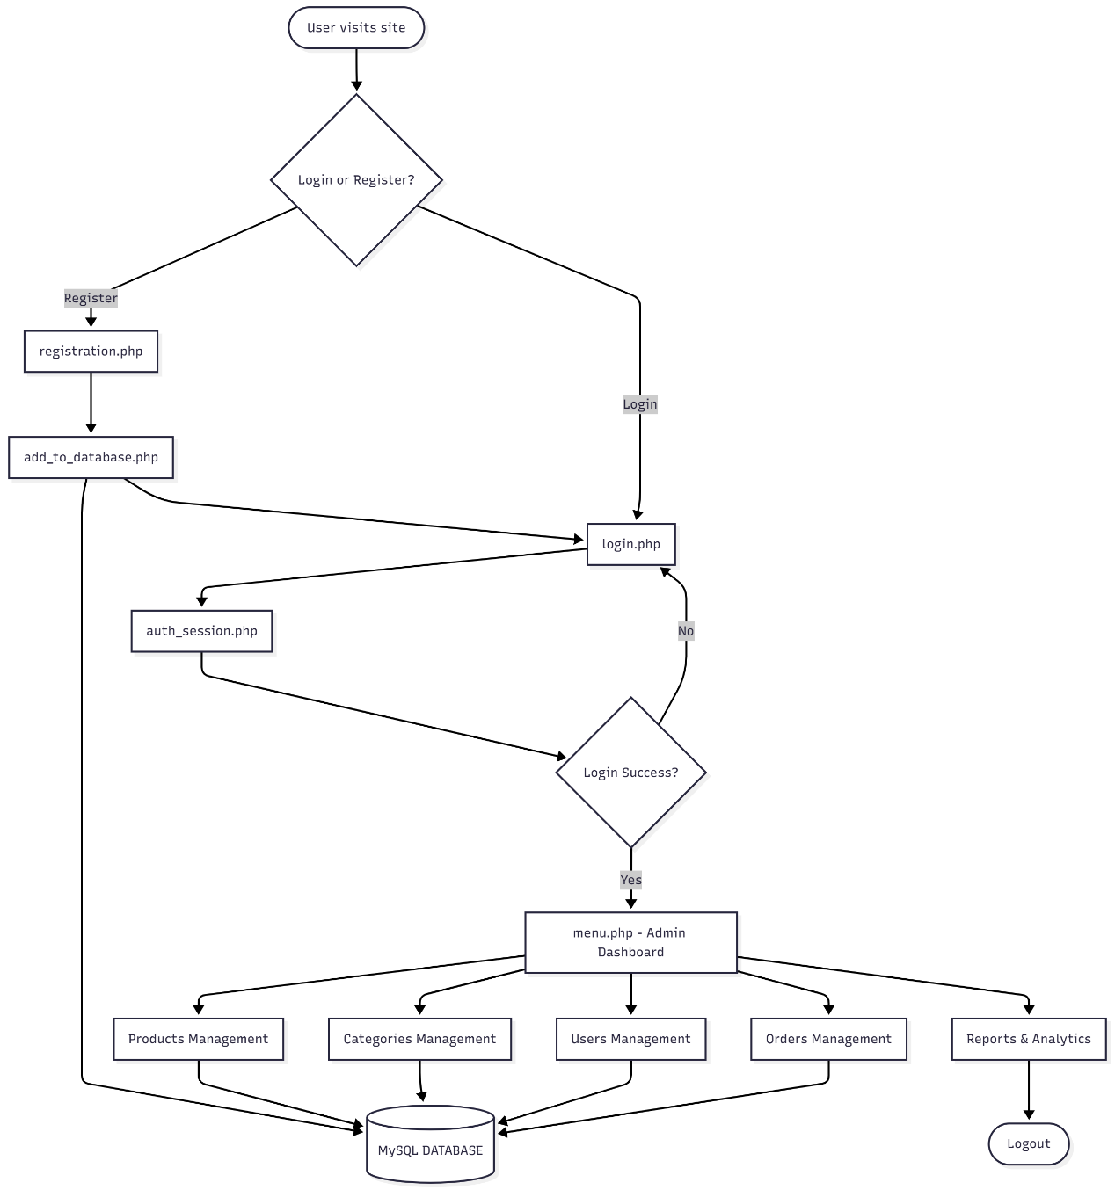
6.1.1 User Flow (Customer Journey)
Below is the step-by-step process a customer follows while using the system:
1. Homepage
- The customer visits the website and lands on the cafe homepage
- The homepage displays:
  - Featured menu items and daily specials
  - Promotional banners for seasonal offers
  - Navigation options: Menu, About Us, Gallery, Contact
  - Login/Register buttons prominently displayed
2. Registration/Login
  - New Users: Sign up by providing, Full name, Email address, Contact number, Password (with confirmation), Delivery address (optional)
- Existing Users: Log in securely using their registered credentials (email and password)
- System validates credentials and creates a secure session
3. Menu Browsing
- Each menu item displays:
  - Item name and description
  - High-quality product image
  - Price
  - Availability status (In Stock/Out of Stock)
  - Customization options (size, add-ons, special instructions)
4. Adding Items to Cart
- User selects desired items and clicks "Add to Cart"
- The digital cart dynamically updates showing:
  - List of selected items with thumbnails
  - Individual item prices
  - Quantity selectors (increase/decrease)
  - Subtotal for each item
5. Checkout Process
- Users review their complete order summary:
  - All selected items with customizations
  - Delivery/pickup option selection
  - Order notes or special instructions
  - Final bill breakdown (subtotal, taxes, delivery charges)
- Users confirm and submit the order
6. Order Confirmation
- System generates:
  - Unique Order ID for tracking
  - Estimated preparation time
  - Order confirmation message with details
- Customer receives notification (on-screen or email)
- Order is sent to the kitchen system for preparation
7. Order Tracking
- Customers can track their order status in real-time:
  - Order Received
  - Being Prepared (In Kitchen)
  - Ready for Pickup/Out for Delivery
  - Completed
- Progress bar or status indicator shows current stage
8. Order History
- Registered users can access their order history showing:
  - Past orders with dates and times
9. Logout
- Users can securely log out when finished
- Session is terminated and cart is cleared (unless saved)

6.1.2 Admin Flow (Management Dashboard)
The admin has complete control over the system's backend operations and business management.
1. Admin Login
- Secure login portal with admin credentials
- Role-based authentication for chef, cashier etc. (admin can do that only)
2. Dashboard Overview
- Central dashboard displaying key metrics:
  - Today's total sales and revenue
  - Number of orders (pending, completed, cancelled)
  - Low stock alerts
3. Menu Management
- Add New Items:
  - Item name, description, category
  - Upload product images
  - Set pricing (base price, variants)
- Update Existing Items:
  - Modify prices, descriptions, images
- Delete Items:
  - Remove discontinued products
4. Order Management
- View all orders in a comprehensive list:
  - Filter by status (Pending, Processing, Completed)
  - Filter by date range
  - Search by Order ID or customer name
- Order Details for each order:
  - Customer information
  - Items ordered with specifications
  - Order timestamp
  - Payment status
  - Delivery/pickup details
- Update Order Status:
  - Mark orders as Processing, Ready, or Completed
5. User Management
- View complete customer database:
  - Customer names, emails, phone numbers
  - Registration dates
  - Order history and purchase patterns
  - Active/inactive status
- Manage user accounts (activate, deactivate, or delete)
- View customer feedback and complaints
6. Staff Management
- Add new staff members (chefs, cashiers)
- Assign roles and permissions
7. Reports and Analytics
- Sales Reports:
  - Daily, weekly, monthly, yearly sales
  - Revenue trends and growth charts
  - Payment method breakdown
8. Settings and Configuration
- Update cafe information (name, address, contact)
- Manage delivery charges and tax rates
- Set business hours and holiday schedules
- Configure email and SMS notifications
- Backup and restore database

6.1.3 Staff Flow - Cashier (Front-of-House Operations)
Cashiers handle in-store customer orders and payment processing.
1. Cashier Login
- Secure login with cashier credentials
- Role-based access (limited to cashier functions)
- Log start of shift time
2. Point of Sale (POS) Dashboard
- Clean, fast interface for quick order entry
- Display current date, time, and cashier name
- Show active orders and queue status
3. Take Customer Order
- In-Store Order Process:
  - Select customer type (walk-in or registered member)
  - Browse menu items quickly via POS interface
  - Add items to order with quantities
  - Apply customizations (size, extras, modifications)
  - Add special instructions from customer
- Member Benefits:
  - Search registered customers by phone or email
  - Apply loyalty points or discounts
  - Show customer's order history for quick reordering
4. Order Summary and Billing
- Review complete order with customer:
  - List all items with prices
  - Show subtotal, taxes, and discounts
  - Calculate and display final total
- Customer can request modifications before confirmation
5. Payment Processing
- Select payment method:
  - Cash
  - Credit/Debit Card
  - Digital Wallets (UPI, PayPal, etc.)
  - Loyalty Points redemption
- Process payment securely
- Handle cash transactions:
  - Enter amount received
  - Calculate change to return
  - Print receipt
6. Generate Invoice/Receipt
- System automatically generates:
  - Order number for kitchen tracking
  - Itemized receipt with cafe branding
  - QR code for order tracking (optional)
- Print or email receipt to customer
- Store transaction record in database
7. Send Order to Kitchen
- Order automatically transmitted to kitchen display system (KDS)
- Kitchen receives:
  - Order number and timestamp
  - Items to prepare with customizations
  - Priority level (regular or urgent)
  - Table number or customer name
8. Order Status Monitoring
- Track orders sent to kitchen:
  - Pending preparation
  - Being prepared
  - Ready for pickup
- Notify customers when orders are ready
- Handle customer inquiries about order status
9. Handle Returns and Complaints
- Process customer complaints about:
  - Wrong items delivered
  - Quality issues
  - Missing items
- Initiate refunds or replacements
- Document issues for manager review
10. End of Shift
- Generate shift summary:
  - Total orders handled
  - Total sales amount
  - Payment method breakdown
  - Cash reconciliation
- Log out from system

6.1.4 Staff Flow - Chef (Kitchen Operations)
Chefs manage food preparation and kitchen workflow through a Kitchen Display System.
1. Chef Login
- Login to Kitchen Display System (KDS)
- Role-based access (kitchen staff only)
- Log start of shift and workstation assignment
2. Kitchen Dashboard
- Real-time order queue display:
  - Pending orders listed by time received
  - Order details clearly visible
  - Color-coded priority levels:
    - Red: Urgent or delayed
    - Yellow: Standard priority
    - Green: Completed
- Display estimated preparation times
- Show current order backlog count
3. Receive New Orders
- Orders automatically appear on KDS from:
  - Online customer orders
  - Cashier POS orders
  - Phone/call-in orders
- Each order shows:
  - Order number
  - Timestamp (order received time)
  - Customer name or table number
  - Complete item list with quantities
  - Customizations and special instructions
  - Allergen warnings or dietary notes
4. Acknowledge Order
- Chef clicks "Accept" or "Start Preparing"
- Order status updates to "In Progress"
- Timer starts automatically for preparation tracking
- System notifies cashier/customer of order acceptance
5. Prepare Order Items
- Follow recipes and preparation guidelines
- Prepare items according to specifications:
  - Correct portions and ingredients
  - Apply customizations (extra shots, no sugar, etc.)
  - Follow special instructions
- Maintain quality standards and presentation
- Check ingredient availability:
  - If item unavailable, mark and notify manager
  - Suggest alternatives to customer via cashier
6. Quality Check
- Verify order completeness:
  - All items prepared as per order
  - Correct customizations applied
  - Proper temperature and presentation
  - Packaging appropriate for delivery/pickup
- Cross-check with order ticket
7. Mark Order as Ready
- Click "Complete" or "Ready" button on KDS
- Order status updates system-wide:
  - Cashier receives notification
  - Customer receives ready notification
  - Order moves to completed queue
- Place order in designated pickup area
- Attach order number for easy identification
8. Inventory Usage Tracking
- System tracks ingredient usage automatically per order:
  - Coffee beans, milk, flour, vegetables used
  - Updates real-time inventory levels
- Chef manually records spoilage or waste
- Alert manager when ingredients run low
9. Handle Rush Hours and Priority Orders
- During peak times:
  - Prioritize orders based on wait time
  - Coordinate with other kitchen staff
  - Communicate delays to front staff
- Special handling for:
  - VIP or premium customer orders
  - Catering or bulk orders
  - Time-sensitive delivery orders
10. Monitor Performance Metrics
- Kitchen dashboard shows:
  - Average preparation time per order
  - Number of orders completed per shift
  - Orders delayed or pending
  - Customer feedback on food quality
- Performance data available to manager for evaluation
11. Kitchen Maintenance
- Log equipment issues or maintenance needs
- Report ingredient quality problems
- Update recipe notes or improvement suggestions
- Clean and organize workstation at shift end
12. End of Shift
- Complete all pending orders
- Handover notes to next shift chef
- Report day's production summary:
  - Total orders prepared
  - Ingredients used
  - Waste recorded
  - Equipment or supply issues
- Log out from KDS

6.2 System Flow Diagrams Summary
User Flow Diagram:
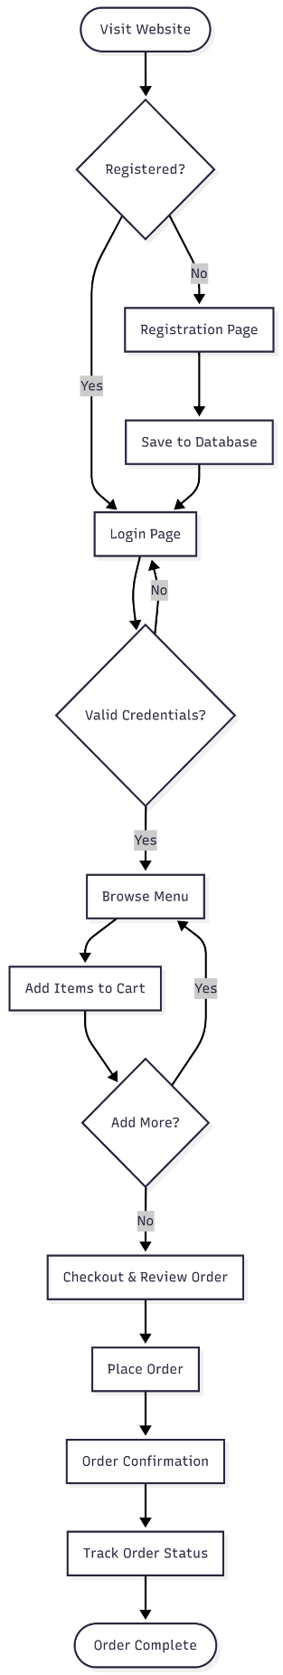

Admin Flow Diagram:
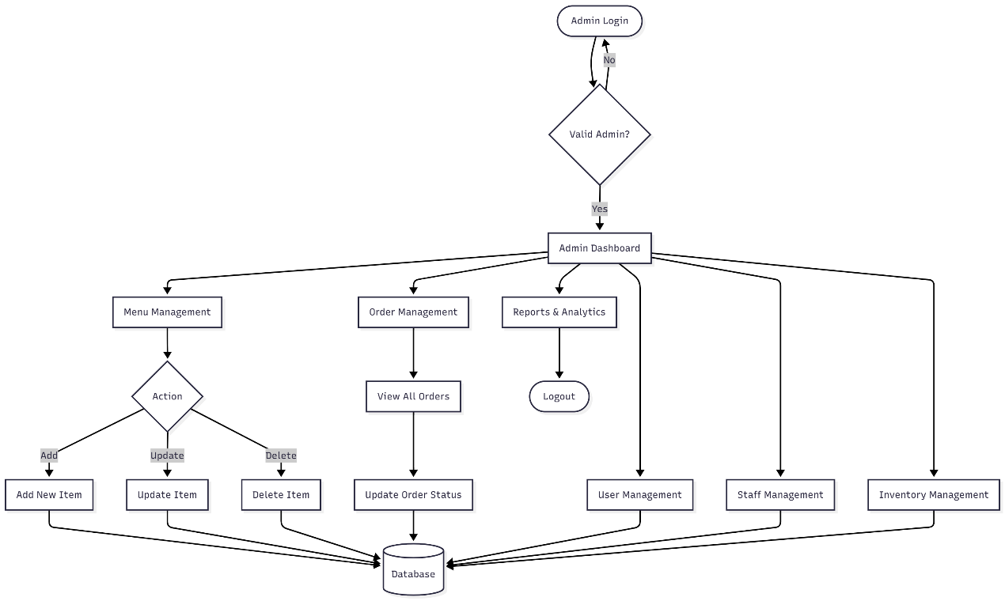

Cashier Flow Diagram:
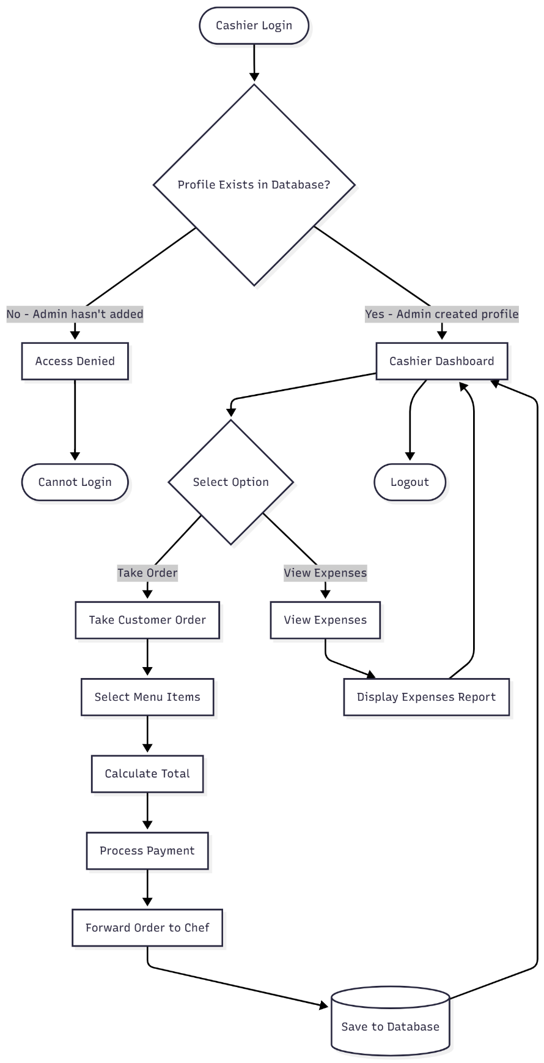

Chef Flow Diagram:
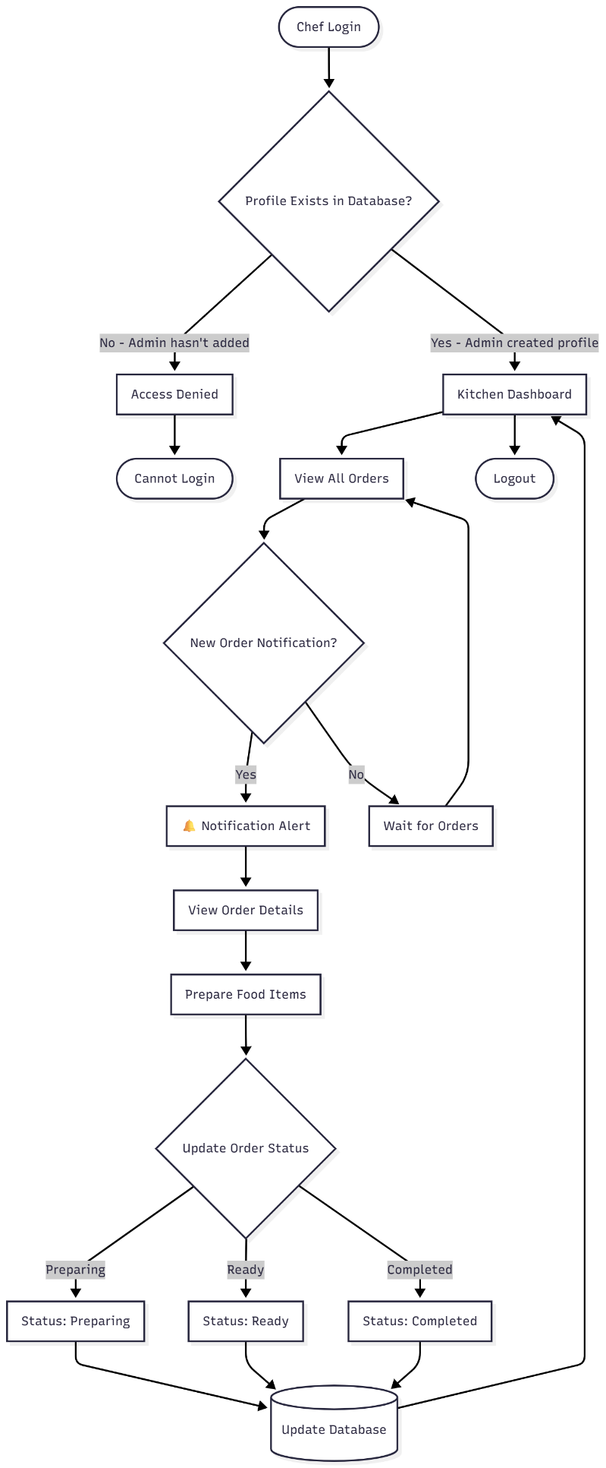
6.3 Component/Module Diagram
The system is divided into functional modules, each handling a specific part of the process:
Module | Functionality
User Module | Handles registration, login, profile management for customers
Menu Module | Displays menu items, categories, pricing, and customization options
Cart Module | Manages item selection, quantity updates, and total calculations
Order Module | Processes order placement, tracking, and history
Admin Module | Provides tools for menu, order, user, and staff management
Cashier Module | POS interface for in-store orders and payment processing
Kitchen Module | Kitchen Display System for order preparation and tracking
Inventory Module | Tracks ingredients, supplies, and stock levels
Reports Module | Generates sales, performance, and analytics reports
Database Module | Stores all customer, order, menu, staff, and inventory data securely

6.4 Database Design
The database design is crucial for managing data efficiently. The system requires a centralized database to store and retrieve data quickly.
Key Database Tables:
- Users Table - Stores customer information
- Staff Table - Stores chef and cashier credentials and roles
- Menu Table - Stores all menu items and details
- Categories Table - Organizes menu items by category
- Orders Table - Records all customer orders
- Order_Items Table - Stores individual items in each order
- Cart Table - Temporary storage for customer selections
- Inventory Table - Tracks ingredients and supplies
- Transactions Table - Records payment details
- Reports Table - Stores generated analytics and reports

6.5 Advantages of the System Design
Feature | Advantage
Modular Architecture | Easier to maintain, scale, and expand
Role-Based Access | Secure separation of user, staff, and admin functions
Real-Time Updates | Orders, inventory, and status reflected instantly
Centralized Database | Efficient data storage and retrieval
User-Friendly Interfaces | Simplifies operations for all user types
Scalable Structure | Supports future features like online payments, delivery tracking, loyalty programs

6.6 Summary
The system design of the Cafe Management System ensures:
- Smooth customer interaction with intuitive navigation
- Efficient backend operations for menu, order, and inventory management
- Streamlined kitchen workflow for chefs with Kitchen Display System
- Fast and accurate cashier operations with POS interface
- Secure, centralized data handling for all operations
- A scalable structure ready for future enhancements
This design lays the foundation for a robust and modern digital management platform for your cafe.

7. Tech Stack
The tech stack is the backbone of any software project. It defines the technologies, frameworks, and tools used to design, develop, and deploy the Cafe Management System. A well-planned tech stack ensures that the system is efficient, scalable, secure, and user-friendly. This system has been built using open-source, reliable, and widely adopted technologies. Below is a detailed explanation of each layer of the tech stack.

7.1 Presentation Layer (Frontend)
The frontend is the part of the system that users (customers, cashiers, chefs, and admins) directly interact with. It focuses on providing an intuitive, visually appealing, and responsive user interface (UI).
Technology | Purpose | Why Used
HTML5 | Structure of web pages and content | Lightweight, semantic markup, easy to integrate, and SEO-friendly
CSS3 | Styling and layout of web pages | Provides modern design with consistent branding, animations, and responsive layouts
JavaScript | Client-side interactivity and dynamic content | Enhances user experience with dynamic cart updates, form validation, and real-time notifications
Bootstrap 5 | Responsive framework for layout and components | Mobile-first design, pre-built components (buttons, forms, modals), and grid system
jQuery | Simplified DOM manipulation and AJAX calls | Makes JavaScript code shorter and more readable, easy AJAX implementation
AJAX | Asynchronous data exchange between client and server | Allows smooth updates without page reloads (e.g., live cart updates, order status)
Frontend Features
- Responsive Web Design
  - Compatible with desktops, tablets, and smartphones
  - Optimized layout for cafe branding and color scheme
  - Mobile-friendly navigation for on-the-go ordering
- Dynamic Cart System
  - Real-time price calculations as users add or remove items
  - Instant quantity updates without page refresh
  - Visual feedback for user actions
- Interactive UI Elements
  - Dropdown menus for menu categories
  - Modal dialogs for order confirmations
  - Toast notifications for success/error messages
  - Buttons with hover effects for better UX
- Real-Time Notifications
  - Instant feedback when orders are placed
  - Status update alerts for customers
  - Kitchen notifications for new orders

7.2 Business Logic Layer (Backend)
The backend manages the core functionality of the system, including user authentication, order processing, menu management, and communication between the frontend and database.
Technology | Purpose | Why Used
PHP 7.4+ | Server-side scripting for business logic | Open-source, widely adopted, excellent MySQL integration, secure session handling
CodeIgniter 4 | PHP MVC framework | Lightweight, fast performance, built-in security features, easy to learn and maintain
Session Management | Manages user sessions securely | Ensures secure and personalized user experiences with role-based access control
RESTful APIs | Future integration with payment gateways and delivery services | Provides scalability and modularity for future upgrades
JSON | Data exchange format | Lightweight data format for AJAX requests and API responses
Backend Responsibilities
- User Authentication & Authorization
  - Secure registration and login handling
  - Password encryption using MD5/SHA-256 hashing
  - Role-based access control (Admin, Cashier, Chef, Customer)
  - Session timeout for security
- Order Management
  - Process customer orders and generate unique order IDs
  - Validate order data before database insertion
  - Update order status dynamically (Pending, Preparing, Ready, Completed)
  - Send real-time notifications to kitchen staff
- Menu Management
  - Add, edit, or delete menu items through admin panel
  - Category management (Hot Beverages, Cold Beverages, Food, Desserts)
  - Price updates and availability control
  - Image upload handling for menu items
- Staff Management
  - Admin creates staff profiles for cashiers and chefs
  - Role assignment and permission management
  - Staff authentication verification
- Data Security
  - Input validation and sanitization to prevent SQL injection
  - XSS (Cross-Site Scripting) protection
  - CSRF (Cross-Site Request Forgery) tokens
  - Secure password storage with encryption

7.3 Data Layer (Database)
The database layer is essential for storing, retrieving, and managing all critical data securely. MySQL has been selected for this project as it is reliable, efficient, and open-source.
Database Technology | Purpose | Why Used
MySQL 8.0+ | Relational database for structured data | Highly efficient, lightweight, scalable, ACID-compliant, supports complex queries
phpMyAdmin | Web-based database management tool | Simplifies database administration, query execution, and table management

Data Stored
The database stores the following information:
Table Name | Data Stored
users | Customer information (ID, name, email, password, phone, address, registration date)
staff | Staff credentials and roles (ID, name, email, password, role: cashier/chef, created_by_admin)
menu_items | All menu items (ID, item name, description, price, category, image, availability)
categories | Menu categories (ID, category name, description, display order)
orders | Order records (ID, customer ID, staff ID, items, total price, status, order timestamp)
order_items | Individual items in each order (ID, order ID, menu item ID, quantity, customizations)
cart | Temporary storage for customer selections before checkout (session-based)
expenses | Business expenses viewable by cashiers (ID, description, amount, date, category)
transactions | Payment records (ID, order ID, payment method, amount, transaction date)
Database Features
- Centralized Data Management: Keeps all customer, staff, order, and menu data in one secure location
- Data Integrity: Primary and foreign key constraints ensure accuracy and prevent duplication
- Real-Time Updates: Reflects menu changes and order statuses immediately across all interfaces
- Scalability: Supports future additions like multi-branch data, online payments, and loyalty programs
- Backup & Recovery: Regular automated backups to prevent data loss
- Indexing: Optimized queries with proper indexing for faster data retrieval

7.4 Development Tools & Environment
Tool/Platform | Purpose
XAMPP | Local development server for PHP and MySQL testing
Visual Studio Code | Primary code editor with extensions (PHP IntelliSense, MySQL, HTML/CSS)
Git & GitHub | Version control system for tracking changes and collaborative development
Browser Developer Tools | Chrome DevTools for testing, debugging frontend designs, and network monitoring
Postman | API testing and debugging tool
Draw.io / Mermaid | Designing flowcharts, ER diagrams, and system architecture diagrams
Composer | PHP dependency management tool

7.5 Additional Libraries & APIs
Library/API | Purpose | Usage
Font Awesome 6 | Icon library | Navigation icons, action buttons, status indicators
Google Fonts | Typography | Modern, stylish fonts for better readability
Chart.js | Data visualization | Admin dashboard analytics and sales reports
DataTables | Enhanced table functionality | Sortable, searchable order and menu management tables
SweetAlert2 | Beautiful alert modals | User-friendly confirmation dialogs and notifications
Moment.js | Date and time formatting | Consistent date/time display across the system

7.6 System Architecture Flow
Step-by-Step Workflow
- User Action
  - Customer/Staff interacts with the frontend interface (browse menu, place order, update status)
- Request to Backend
  - Data is sent via PHP/AJAX to the backend for processing
  - Session validation checks user authentication and role permissions
- Processing Logic
  - Backend validates input data and applies business rules
  - Generates unique IDs for orders/transactions
  - Calculates totals, taxes, and discounts
- Database Update
  - MySQL stores/updates order, customer, menu, and staff details securely
  - Database triggers ensure data consistency
- Response to Frontend
  - Backend sends confirmation or error messages
  - Frontend displays results with visual feedback
  - Real-time notifications update relevant dashboards

7.7 Security Measures
Security Feature | Implementation
Password Encryption | MD5/SHA-256 hashing for stored passwords
SQL Injection Prevention | Prepared statements and parameterized queries
XSS Protection | Input sanitization and output encoding
CSRF Protection | Token-based validation for form submissions
Session Security | Secure session cookies with timeout
Role-Based Access | Different permission levels for admin/staff/customers
HTTPS Support | SSL certificate for production deployment
Input Validation | Server-side and client-side validation

7.8 Summary of Tech Stack Benefits
Layer | Benefits
Frontend | Provides responsive, mobile-friendly, and intuitive user interface for all roles
Backend | Ensures robust order processing, secure authentication, and efficient business logic
Database | Centralizes all data securely with high performance and scalability
Tools | Enhance productivity, debugging, version control, and collaboration
Security | Protects sensitive customer and business data from vulnerabilities

7.9 Future Technology Enhancements
The system is designed to easily integrate future technologies:
- Payment Gateway Integration: Razorpay, PayPal, Stripe for online payments
- SMS/Email API: Twilio, SendGrid for order notifications
- Progressive Web App (PWA): Offline functionality and mobile app-like experience
- Cloud Hosting: AWS, Google Cloud, or Azure for scalability
- AI Recommendations: Machine learning for personalized menu suggestions
- Delivery Tracking: Google Maps API integration for real-time order tracking
- Mobile Apps: React Native or Flutter for native Android/iOS apps

Conclusion
The Cafe Management System leverages a powerful, lightweight, and secure tech stack to ensure:
- A seamless user experience for customers, cashiers, chefs, and admins
- Reliable backend processes for order and staff management
- Efficient data handling with MySQL database
- Flexibility to integrate future features like online payments, delivery tracking, and multi-branch support

8. Screenshots
Screenshots provide visual documentation of the Cafe Management System's interface and functionality. This section demonstrates the implementation of features across different user roles: Admin, Cashier, and Chef. Each screenshot validates the working system and showcases the user experience.

8.1 Home Page / Landing Page
Description:
The entry point of the Cafe Management System where users can access login functionality or learn about the cafe.
Key Elements:
- Welcome banner with cafe branding
- "Login" button prominently displayed
- Cafe introduction section
- Navigation menu (if available for guests)
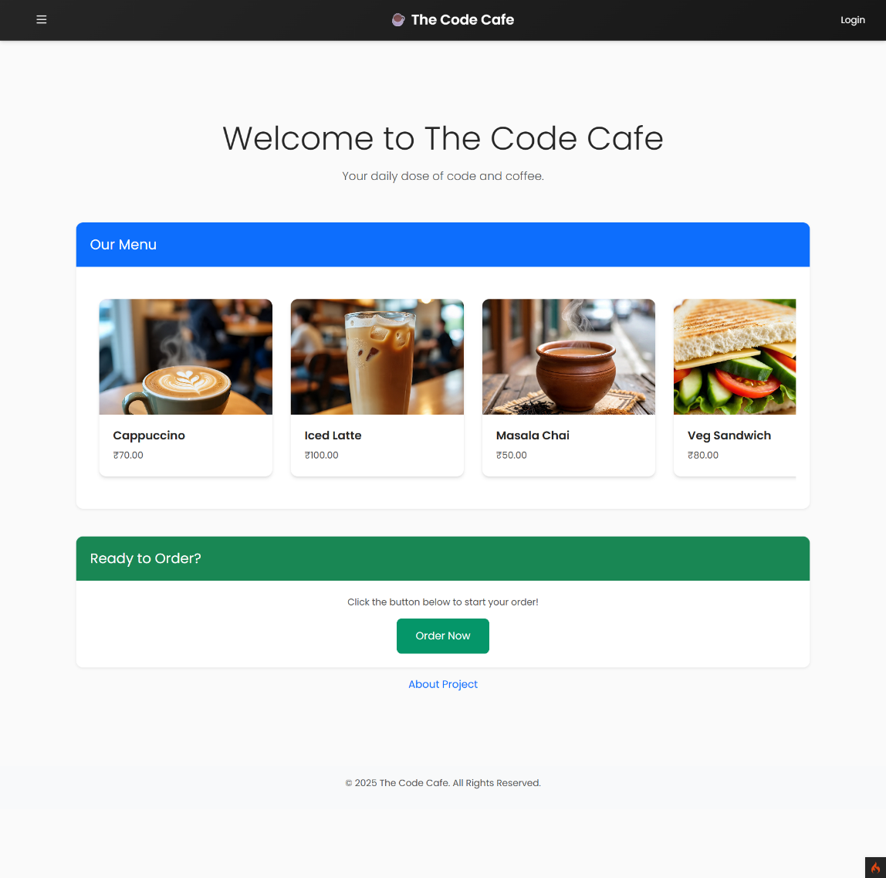
Purpose:
- First impression for all visitors
- Gateway to authentication system
- Brand representation
8.2 Login Page
Description:
Secure authentication page for all user types (Admin, Cashier, Chef).
Key Elements:
- Login form with fields:
  - Email/Username input
  - Password input (with show/hide toggle)
- "Login" button
- Form validation error messages
- "Forgot Password" link (if implemented)
- Session management indicators
- Professional cafe-themed design

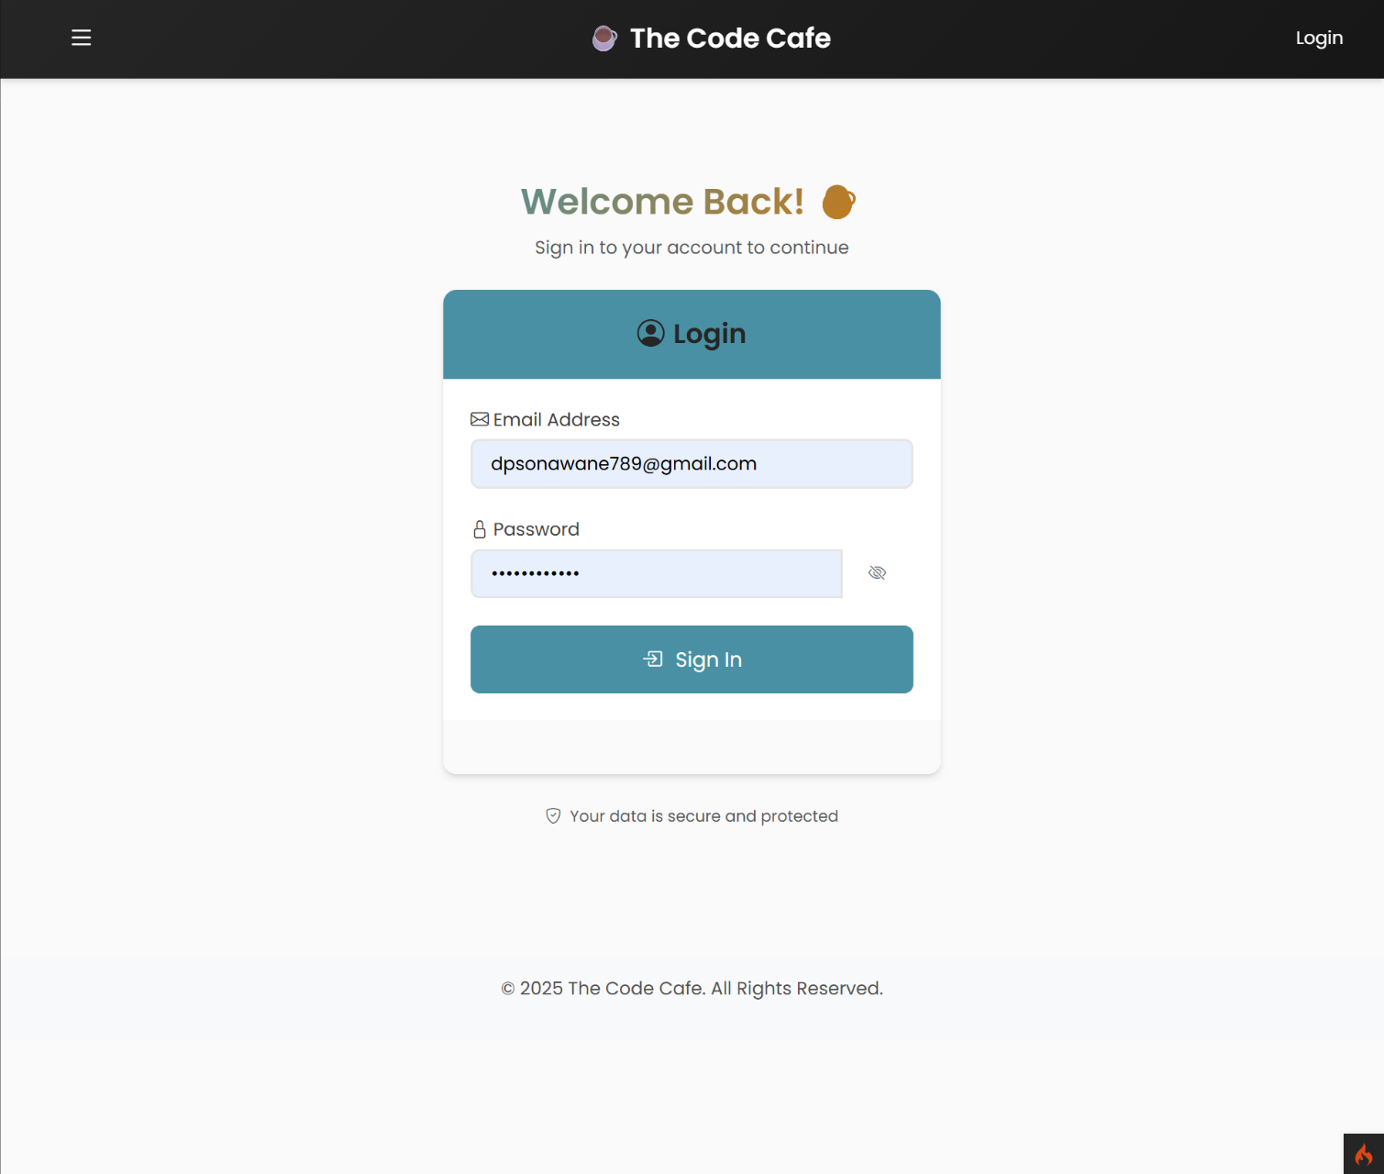
Technical Details:
- PHP session handling
- Role-based authentication check
- Redirect based on user role:
  - Admin → Admin Dashboard
  - Cashier → Cashier Dashboard
  - Chef → Kitchen Display System
Purpose:
- Secure access control
- Role verification
- Session initialization

8.3 Admin Dashboard
Description:
Central control panel showing key business metrics and quick access to management functions.
Key Elements:
- Statistics cards displaying:
  - Total Orders Today
  - Today's Revenue
  - Total Products Available
  - Total Active Staff
  - Pending Orders Count
- Quick action navigation cards:
  - Manage Categories
  - Manage Products
  - View Orders
  - Manage Staff (Cashier & Chef)
  - View Expenses
  - Generate Reports
- Recent orders summary table
- Welcome message with admin name
- Logout button

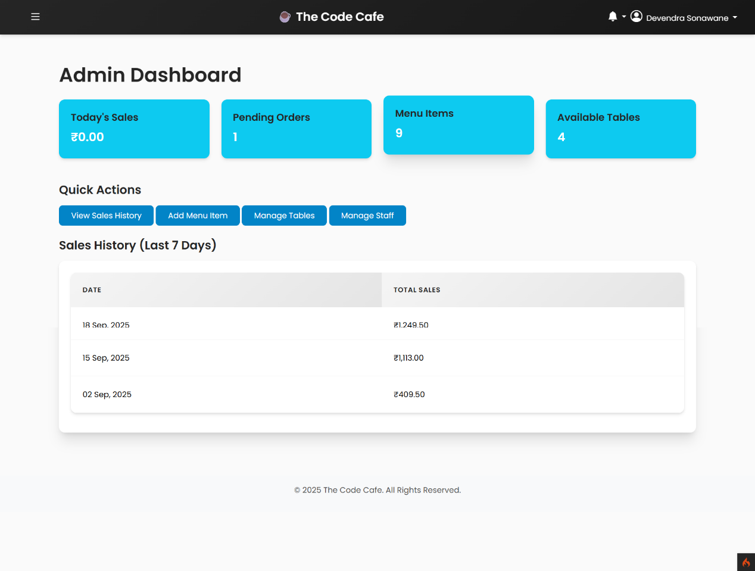
Database Tables Used: orders, products, staff, categories
Purpose:
- At-a-glance business overview
- Quick navigation to management features
- Real-time operational metrics

8.3 Cashier Dashboard / POS Interface
Description:
Point-of-sale interface for taking in-store customer orders.
Key Elements:
- Product grid/list view:
  - Product images
  - Product names
  - Prices
  - Quick "Add to Order" buttons
- Category filter tabs/buttons
- Search product bar
- Current order panel (right sidebar):
  - Selected items list
  - Quantity controls (+/-)
  - Remove item button
  - Subtotal, Tax, Grand Total
- Customer selection:
  - Walk-in customer (default)
  - Registered member search (optional)
- Action buttons:
  - "Add More Items"
  - "Clear Order"
  - "Process Payment"
- Payment processing modal:
  - Total amount display
  - Payment method buttons (Cash, Card, UPI)
  - Amount received input (for cash)
  - Change calculation
  - "Complete Order" button
- Order confirmation with order number
- "Send to Kitchen" button

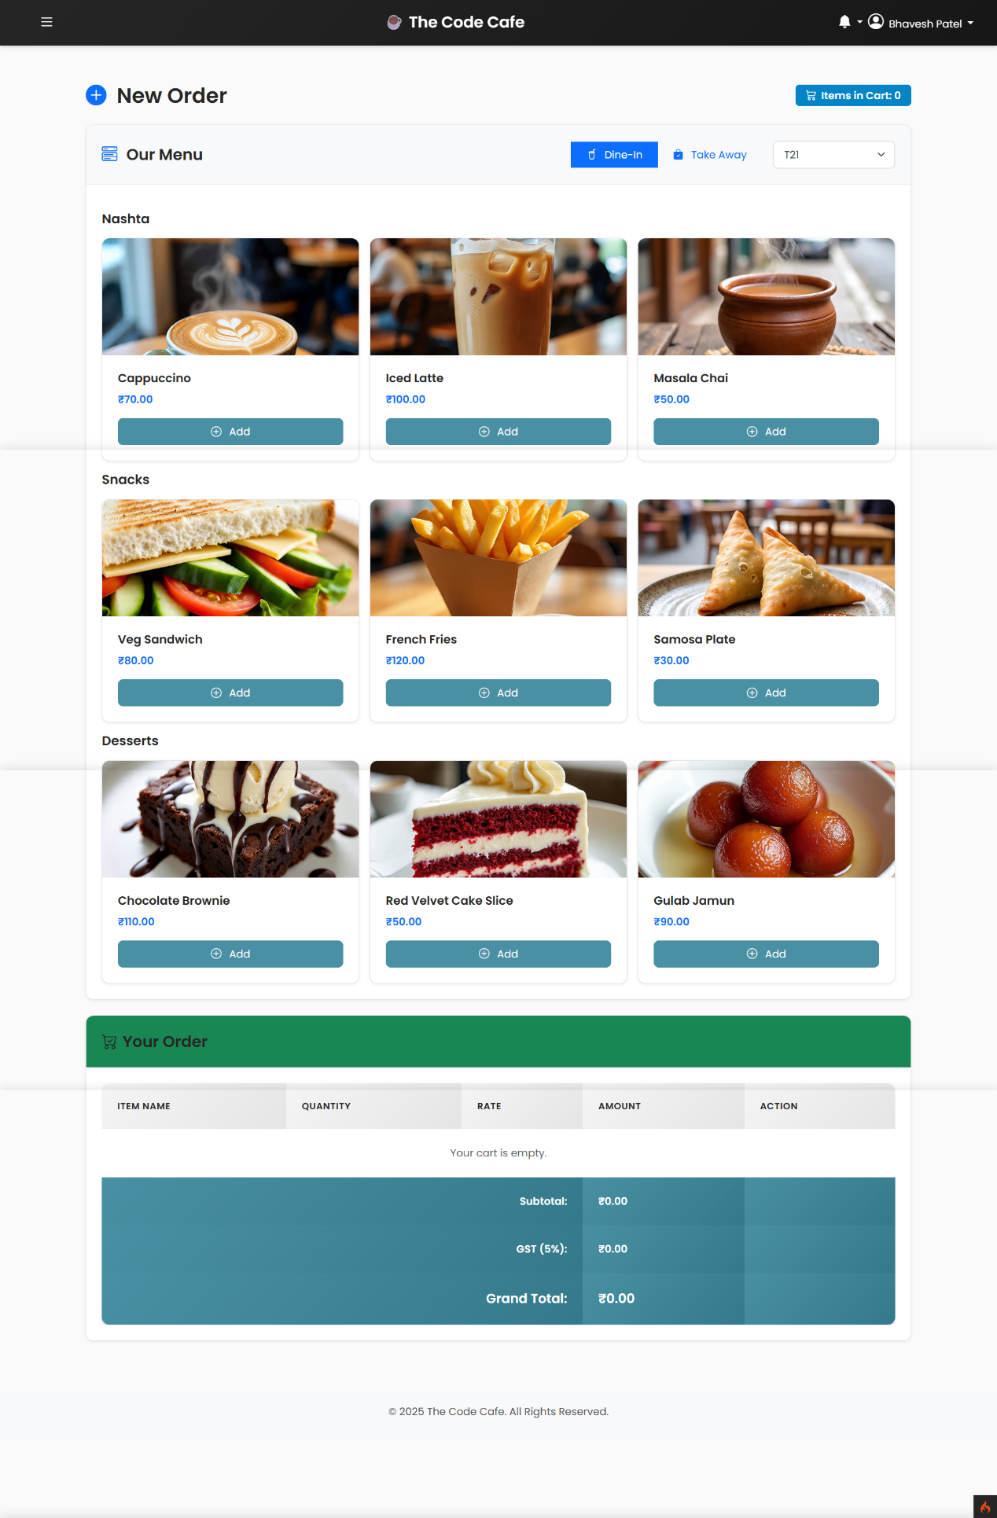

Purpose:
- Fast order entry for in-store customers
- Calculate totals with tax automatically
- Process payments
- Forward orders to kitchen
- Generate order receipts
Access Control: Only staff with "Cashier" role can access

8.4 Cashier - View Expenses
Description:
Read-only view for cashiers to see business expenses.
Key Elements:
- Expenses table (read-only):
  - Date
  - Category
  - Description
  - Amount
- Filter by date range
- Filter by category
- Total expenses display
- No add/edit/delete buttons (view-only)

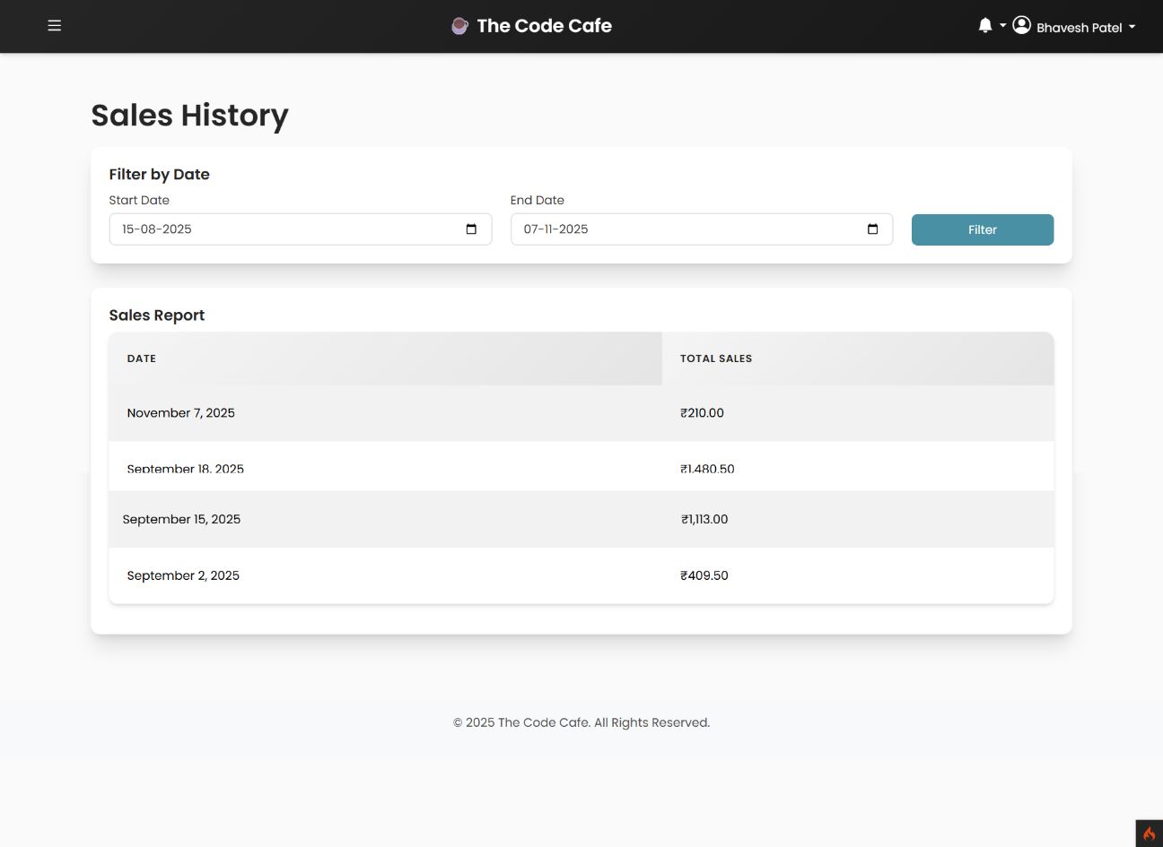
Purpose:
- Provide expense transparency to cashiers
- Help understand operational costs
- Financial awareness
Access Control: Cashier can view only, not modify

8.5 Chef - Order Status Update
Description:
Interface for chefs to update order progress status.
Key Elements:
- Order detail view showing:
  - Order number
  - Order items
  - Current status
- Status update buttons/dropdown:
  - Preparing
  - Ready for Pickup
  - Completed
- "Update Status" button
- Confirmation message after update
- Ingredient availability checkbox
- Notes field for issues (e.g., "Out of ingredient X")
- Timestamp of last status change
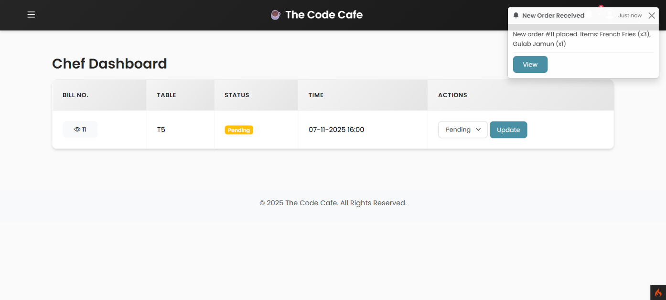
Purpose:
- Keep order status current
- Notify cashiers/customers when orders are ready
- Track kitchen efficiency
- Communication between kitchen and front-of-house
Status Flow: Pending → Preparing → Ready → Completed

8.6 Receipt / Order Invoice
Description:
Printable receipt generated after order completion.
Key Elements:
- Cafe header with:
  - Cafe name and logo
  - Address and contact number
  - GST/Tax ID (if applicable)
- Receipt details:
  - Order number
  - Date and time
  - Cashier name
- Items table:
  - Item name
  - Quantity
  - Unit price
  - Amount
- Pricing breakdown:
  - Subtotal
  - Tax/GST amount
  - Grand Total
- Payment method (Cash, Card, UPI)
- ‘Thank you’ message.

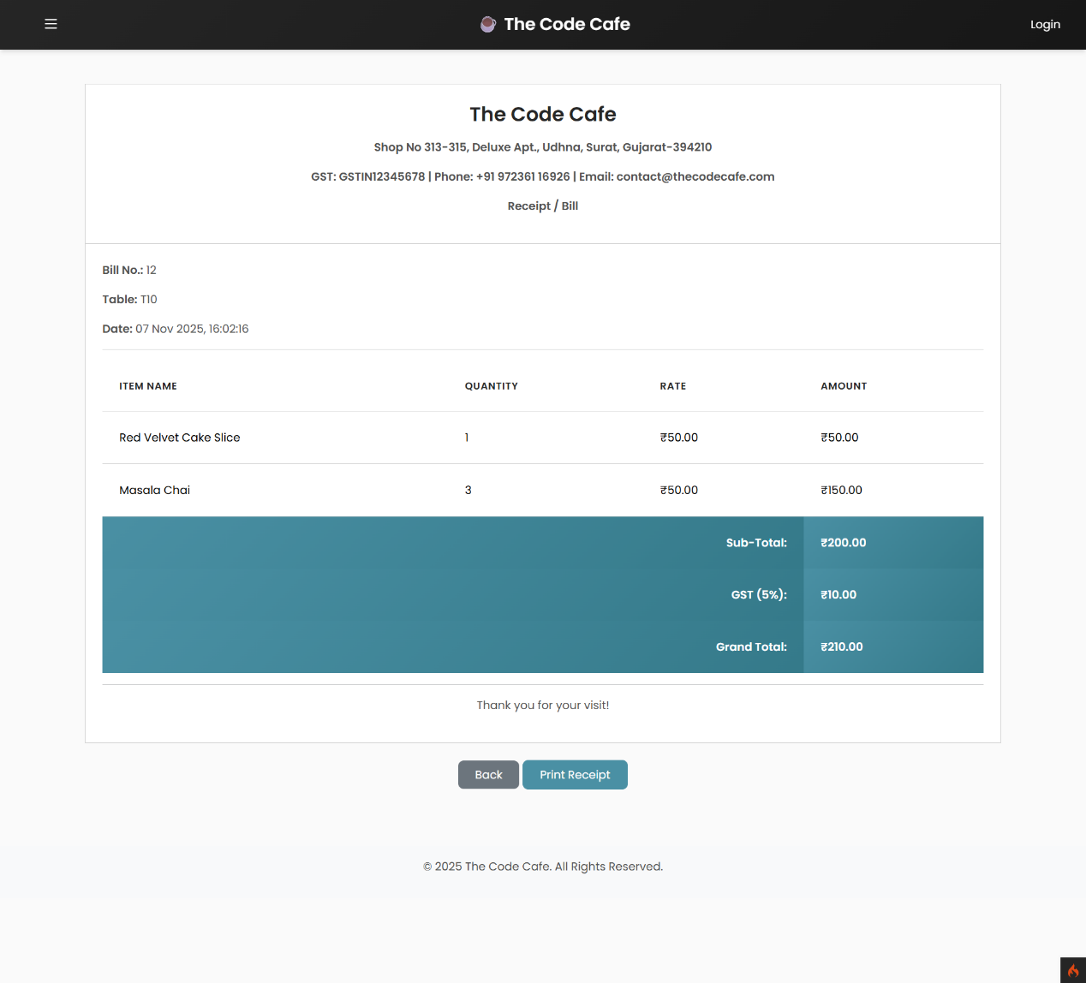Purpose:
- Provide customer with payment proof
- Record keeping
- Professional appearance
Generation: Auto-generated after payment, printable via browser

8.7 Database Structure (phpMyAdmin Screenshot)
Description:
Visual representation of the database schema in phpMyAdmin.
Key Elements:
- Database name: cafe_management_system or similar
- Tables list with row counts:
  - users / staff - Staff credentials
  - categories - Product categories
  - products - Menu items
  - orders - Order records
  - order_items - Individual items per order
  - expenses - Business expenses
  - transactions - Payment records (if separate)
- Table structure views showing:
  - Column names
  - Data types (INT, VARCHAR, DECIMAL, DATETIME, etc.)
  - Keys (PRIMARY, FOREIGN, UNIQUE)
  - NULL/NOT NULL constraints
  - Default values
  - Auto-increment settings
- Sample data rows in tables
- Relationships diagram (if available)

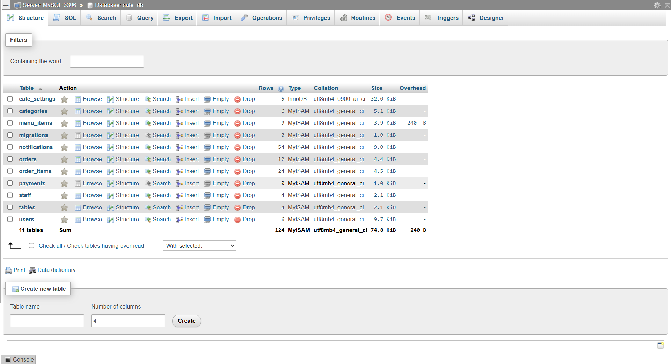
Purpose:
- Document database design
- Show data organization
- Technical implementation proof
- Reference for future development

8.8 Responsive Mobile View (Optional)
Description:
Screenshots showing mobile-optimized layouts.
Key Elements:
- Mobile login page
- Mobile menu browsing
- Mobile order interface
- Touch-friendly buttons
- Hamburger menu navigation
- Stacked layout for narrow screens
Purpose:
- Demonstrate responsive design
- Mobile-first approach
- Cross-device compatibility
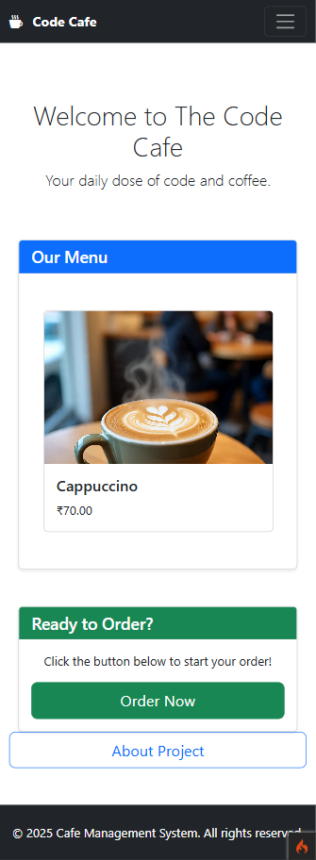

8.18 Profile Settings (Optional)
Description:
User profile management page.
Key Elements:
- User information display
- Edit profile form
- Change password section
- Profile picture upload (optional)
- Save changes button
Available For:
- Admin
- Staff (Cashier, Chef)
Purpose:
- Personal information management
- Security through password updates
- User control over account
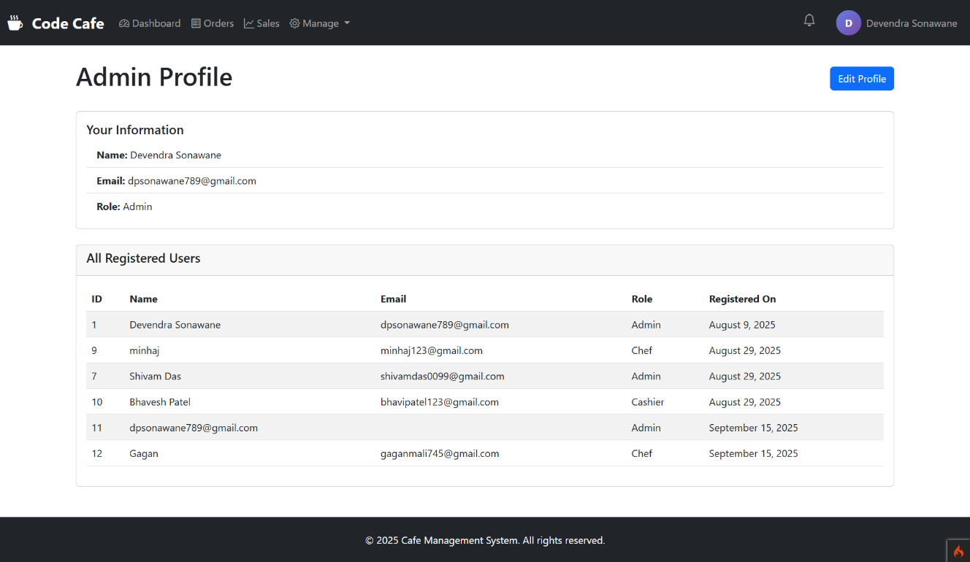

9. Coding
This section provides important code snippets that implement the core functionality of the Cafe Management System. These code examples demonstrate the actual implementation of key features including database connectivity, user authentication, order management, and role-based access control for Admin, Cashier, and Chef.

9.1 Database Connection
File: app/Config/Database.php (CodeIgniter) or includes/db.php
Purpose: Establishes a secure connection to the MySQL database.
  - <?php
  - // Database Configuration
  - $servername = "localhost";
  - $username = "root";
  - $password = "";
  - $dbname = "cafe_management_system";
  - // Create connection
  - $conn = mysqli_connect($servername, $username, $password, $dbname);
  - // Check connection
  - if (!$conn) {
  - die("Connection failed: " . mysqli_connect_error());
  - }
  - echo "Connected successfully";
  - ?>
Key Points:
- Uses mysqli_connect() for secure database connection
- Handles connection errors gracefully
- Essential for all database operations throughout the system

9.2 User Registration (Staff Creation by Admin)
File: app/Controllers/StaffController.php or admin/add_staff.php
Purpose: Allows admin to create staff profiles for Cashiers and Chefs.

  - <?php
  - require 'db.php';

  - // When form is submitted
  - if (isset($_POST['register_staff'])) {
  - $name = mysqli_real_escape_string($conn, stripslashes($_POST['name']));
  - $email = mysqli_real_escape_string($conn, stripslashes($_POST['email']));
  - $password = mysqli_real_escape_string($conn, stripslashes($_POST['password']));
  - $role = mysqli_real_escape_string($conn, stripslashes($_POST['role'])); // 'cashier' or 'chef'
  - $phone = mysqli_real_escape_string($conn, stripslashes($_POST['phone']));
  - $created_at = date('Y-m-d H:i:s');

  - // Check if email already exists
  - $check_query = "SELECT * FROM staff WHERE email = '$email'";
  - $check_result = mysqli_query($conn, $check_query);

  - if (mysqli_num_rows($check_result) > 0) {
  - echo "<script>alert('Email already exists!');</script>";
  - } else {
  - // Hash password for security
  - $hashed_password = md5($password); // Use password_hash() for better security

  - // Insert staff data
  - $query = "INSERT INTO staff (name, email, password, role, phone, created_at)
  - VALUES ('$name', '$email', '$hashed_password', '$role', '$phone', '$created_at')";

  - $result = mysqli_query($conn, $query);

  - if ($result) {
  - echo "<script>
  - alert('Staff member registered successfully!');
  - window.location.href = 'manage_staff.php';
  - </script>";
  - } else {
  - echo "<script>alert('Registration failed. Please try again.');</script>";
  - }
  - }
  - }
  - ?>
Key Features:
- Admin-only functionality
- Validates email uniqueness
- Encrypts password before storage
- Assigns role (Cashier or Chef)
- Stores staff data in staff table

9.3 Login Authentication (Role-Based)
File: app/Controllers/AuthController.php or login.php
Purpose: Authenticates users and redirects based on their role (Admin/Cashier/Chef).
  - <?php
  - require 'db.php';
  - session_start();

  - if (isset($_POST['login'])) {
  - $email = mysqli_real_escape_string($conn, stripslashes($_POST['email']));
  - $password = mysqli_real_escape_string($conn, stripslashes($_POST['password']));

  - // Hash password
  - $hashed_password = md5($password);

  - // Check in staff table (Admin, Cashier, Chef)
  - $query = "SELECT * FROM staff WHERE email = '$email' AND password = '$hashed_password'";
  - $result = mysqli_query($conn, $query);

  - if (mysqli_num_rows($result) == 1) {
  - $user = mysqli_fetch_assoc($result);

  - // Set session variables
  - $_SESSION['user_id'] = $user['id'];
  - $_SESSION['name'] = $user['name'];
  - $_SESSION['email'] = $user['email'];
  - $_SESSION['role'] = $user['role'];

  - // Redirect based on role
  - if ($user['role'] == 'admin') {
  - header("Location: admin/dashboard.php");
  - } elseif ($user['role'] == 'cashier') {
  - header("Location: cashier/dashboard.php");
  - } elseif ($user['role'] == 'chef') {
  - header("Location: chef/kds.php");
  - }
  - exit();
  - } else {
  - echo "<script>alert('Invalid email or password!');</script>";
  - }
  - }
  - ?>
Key Features:
- Role-based authentication
- Secure session management
- Password encryption verification
- Automatic redirection to appropriate dashboard
- Prevents unauthorized access

9.4 Session Check (Access Control)
File: includes/auth_check.php
Purpose: Ensures only logged-in users with correct roles can access certain pages.
  - <?php
  - session_start();

  - // Check if user is logged in
  - if (!isset($_SESSION['user_id'])) {
  - header("Location: ../login.php");
  - exit();
  - }

  - // Function to check specific role
  - function checkRole($required_role) {
  - if ($_SESSION['role'] != $required_role) {
  - echo "<script>
  - alert('Access Denied! You do not have permission to view this page.');
  - window.location.href = '../login.php';
  - </script>";
  - exit();
  - }
  - }

  - // Example usage in admin pages:
  - // checkRole('admin');

  - // Example usage in cashier pages:
  - // checkRole('cashier');

  - // Example usage in chef pages:
  - // checkRole('chef');
  - ?>
Usage Example:
  - <?php
  - require 'includes/auth_check.php';
  - checkRole('cashier'); // Only cashiers can access this page
  - ?>

9.5 Admin - Add Product/Menu Item
File: admin/add_product.php
Purpose: Allows admin to add new menu items to the cafe catalog.
  - <?php
  - require 'db.php';
  - require 'auth_check.php';
  - checkRole('admin');

  - if (isset($_POST['add_product'])) {
  - $name = mysqli_real_escape_string($conn, $_POST['product_name']);
  - $category = mysqli_real_escape_string($conn, $_POST['category']);
  - $description = mysqli_real_escape_string($conn, $_POST['description']);
  - $price = mysqli_real_escape_string($conn, $_POST['price']);
  - $status = mysqli_real_escape_string($conn, $_POST['status']); // 'available' or 'unavailable'

  - // Handle image upload
  - $image = $_FILES['product_image']['name'];
  - $target = "uploads/" . basename($image);

  - if (move_uploaded_file($_FILES['product_image']['tmp_name'], $target)) {
  - $query = "INSERT INTO products (name, category, description, price, image, status)
  - VALUES ('$name', '$category', '$description', '$price', '$image', '$status')";
  - if (mysqli_query($conn, $query)) {
  - echo "<script>
  - alert('Product added successfully!');
  - window.location.href = 'manage_products.php';
  - </script>";
  - } else {
  - echo "<script>alert('Error adding product.');</script>";
  - }
  - } else {
  - echo "<script>alert('Failed to upload image.');</script>";
  - }
  - }
  - ?>
Key Features:
- Admin-only access
- Image upload handling
- Validates and sanitizes input
- Stores product data with availability status

9.6 Cashier - Take Order (POS System)
File: cashier/create_order.php
Purpose: Cashier creates order and sends it to the kitchen.
  - <?php
  - require 'db.php';
  - require 'auth_check.php';
  - checkRole('cashier');

  - // Receive order data via AJAX/POST
  - $order_data = json_decode(file_get_contents("php://input"), true);

  - $cashier_id = $_SESSION['user_id'];
  - $customer_name = mysqli_real_escape_string($conn, $order_data['customer_name']);
  - $order_items = $order_data['items']; // Array of items
  - $total_amount = 0;
  - $order_date = date('Y-m-d H:i:s');

  - // Calculate total
  - foreach ($order_items as $item) {
  - $total_amount += $item['price'] * $item['quantity'];
  - }

  - // Insert order into database
  - $order_query = "INSERT INTO orders (customer_name, cashier_id, total_amount, order_date, status)
  - VALUES ('$customer_name', '$cashier_id', '$total_amount', '$order_date', 'pending')";

  - if (mysqli_query($conn, $order_query)) {
  - $order_id = mysqli_insert_id($conn);

  - // Insert order items
  - foreach ($order_items as $item) {
  - $product_id = $item['id'];
  - $quantity = $item['quantity'];
  - $price = $item['price'];
  - $subtotal = $price * $quantity;

  - $item_query = "INSERT INTO order_items (order_id, product_id, quantity, price, subtotal)
  - VALUES ('$order_id', '$product_id', '$quantity', '$price', '$subtotal')";
  - mysqli_query($conn, $item_query);
  - }

  - echo json_encode([
  - 'success' => true,
  - 'order_id' => $order_id,
  - 'message' => 'Order placed successfully!'
  - ]);
  - } else {
  - echo json_encode([
  - 'success' => false,
  - 'message' => 'Failed to place order.'
  - ]);
  - }
  - ?>
Key Features:
- Cashier-specific functionality
- Processes multiple items in single order
- Generates unique order ID
- Calculates total automatically
- Sends order to kitchen (status: pending)

9.7 Cashier - View Expenses
File: cashier/view_expenses.php
Purpose: Cashier can view business expenses (read-only).
  - <?php
  - require 'db.php';
  - require 'auth_check.php';
  - checkRole('cashier');

  - // Fetch expenses from database
  - $query = "SELECT * FROM expenses ORDER BY date DESC";
  - $result = mysqli_query($conn, $query);

  - // Display expenses in table
  - echo "<table border='1'>
  - <tr>
  - <th>Date</th>
  - <th>Category</th>
  - <th>Description</th>
  - <th>Amount (₹)</th>
  - </tr>";

  - while ($row = mysqli_fetch_assoc($result)) {
  - echo "<tr>
  - <td>{$row['date']}</td>
  - <td>{$row['category']}</td>
  - <td>{$row['description']}</td>
  - <td>{$row['amount']}</td>
  - </tr>";
  - }

  - echo "</table>";

  - // Calculate total
  - $total_query = "SELECT SUM(amount) as total FROM expenses";
  - $total_result = mysqli_query($conn, $total_query);
  - $total = mysqli_fetch_assoc($total_result)['total'];

  - echo "<h3>Total Expenses: ₹$total</h3>";
  - ?>
Key Features:
- Read-only access for cashiers
- Displays all expense records
- Shows total expense summary
- No add/edit/delete options for cashier

9.8 Chef - View Orders (Kitchen Display System)
File: chef/kds.php
Purpose: Chef views incoming orders in real-time.
  - <?php
  - require 'db.php';
  - require 'auth_check.php';
  - checkRole('chef');

  - // Fetch all pending and preparing orders
  - $query = "SELECT o.*, GROUP_CONCAT(CONCAT(oi.quantity, 'x ', p.name) SEPARATOR ', ') as items
  - FROM orders o
  - LEFT JOIN order_items oi ON o.id = oi.order_id
  - LEFT JOIN products p ON oi.product_id = p.id
  - WHERE o.status IN ('pending', 'preparing')
  - GROUP BY o.id
  - ORDER BY o.order_date ASC";

  - $result = mysqli_query($conn, $query);

  - echo "<h2>Kitchen Orders</h2>";

  - while ($order = mysqli_fetch_assoc($result)) {
  - $order_id = $order['id'];
  - $customer_name = $order['customer_name'];
  - $items = $order['items'];
  - $status = $order['status'];
  - $order_time = $order['order_date'];

  - // Calculate time elapsed
  - $time_diff = time() - strtotime($order_time);
  - $minutes = floor($time_diff / 60);

  - echo "<div class='order-card' style='border: 2px solid " . ($status == 'pending' ? 'green' : 'orange') . ";'>
  - <h3>Order #$order_id</h3>
  - <p><strong>Customer:</strong> $customer_name</p>
  - <p><strong>Items:</strong> $items</p>
  - <p><strong>Status:</strong> $status</p>
  - <p><strong>Time Elapsed:</strong> $minutes minutes</p>
  - <button onclick='updateStatus($order_id, \"preparing\")'>Start Preparing</button>
  - <button onclick='updateStatus($order_id, \"ready\")'>Mark as Ready</button>
  - <button onclick='updateStatus($order_id, \"completed\")'>Complete</button>
  - </div>";
  - }
  - ?>

  - <script>
  - // Auto-refresh page every 10 seconds
  - setTimeout(function() {
  - location.reload();
  - }, 10000);

  - // Function to update order status
  - function updateStatus(orderId, newStatus) {
  - if (confirm('Update order status to: ' + newStatus + '?')) {
  - window.location.href = 'update_order_status.php?order_id=' + orderId + '&status=' + newStatus;
  - }
  - }
  - </script>
Key Features:
- Displays orders in queue
- Shows time elapsed since order received
- Color-coded by status
- Auto-refresh for real-time updates
- Quick status update buttons

9.9 Database Schema (SQL)
Purpose: Create the necessary database tables for the system.
-- Create Database
CREATE DATABASE cafe_management_system;
USE cafe_management_system;
-- Staff Table (Admin, Cashier, Chef)
CREATE TABLE staff (
id INT(11) NOT NULL AUTO_INCREMENT,
name VARCHAR(100) NOT NULL,
email VARCHAR(100) NOT NULL UNIQUE,
password VARCHAR(255) NOT NULL,
role ENUM('admin', 'cashier', 'chef') NOT NULL,
phone VARCHAR(15),
created_at DATETIME NOT NULL,
PRIMARY KEY (id)
) ENGINE=InnoDB DEFAULT CHARSET=utf8mb4;

-- Categories Table
CREATE TABLE categories (
id INT(11) NOT NULL AUTO_INCREMENT,
name VARCHAR(100) NOT NULL,
description TEXT,
status ENUM('active', 'inactive') DEFAULT 'active',
PRIMARY KEY (id)
) ENGINE=InnoDB DEFAULT CHARSET=utf8mb4;

10. References
This section provides essential references to the technologies, frameworks, and resources used in developing the Cafe Management System.

10.1 Official Documentation
Technology | Website
PHP | https://www.php.net/docs.php
CodeIgniter 4 | https://codeigniter.com/user_guide/
MySQL | https://dev.mysql.com/doc/
Bootstrap 5 | https://getbootstrap.com/docs/
JavaScript | https://developer.mozilla.org/en-US/docs/Web/JavaScript
jQuery | https://api.jquery.com/

10.2 Libraries and Tools Used
Library/Tool | Purpose
phpMyAdmin | Database management - https://www.phpmyadmin.net/

10.3 Development Environment
Tool | Website
XAMPP | https://www.apachefriends.org/
Visual Studio Code | https://code.visualstudio.com/
Git & GitHub | https://github.com/
Postman | https://www.postman.com/

10.4 Learning Resources
Resource | Website
W3Schools | https://www.w3schools.com/
MDN Web Docs | https://developer.mozilla.org/
Stack Overflow | https://stackoverflow.com/
YouTube Tutorials | https://www.youtube.com/

10.5 Project Repository
- GitHub Repository: https://github.com/DevSon1024/cafe-management-system

10.6 Security References
Topic | Resource
Password Hashing | https://www.php.net/manual/en/function.password-hash.php
SQL Injection Prevention | https://www.php.net/manual/en/security.database.sql-injection.php
Session Security | https://www.php.net/manual/en/book.session.php
OWASP Security | https://owasp.org/

10.7 Design Resources
Resource | Website
Google Fonts | https://fonts.google.com/

10.8 Flowchart Tools
Tool | Website
Mermaid Live Editor | https://mermaid.live/

